ASSIGNMENT 4

1. C++ Program to Find the Length of a String

PROGRAM:

#include<iostream>

using namespace std;

int main()

{

string str="how dare u to touch my boo";

cout<<"length of str: "<<str.size();

return 0;

}

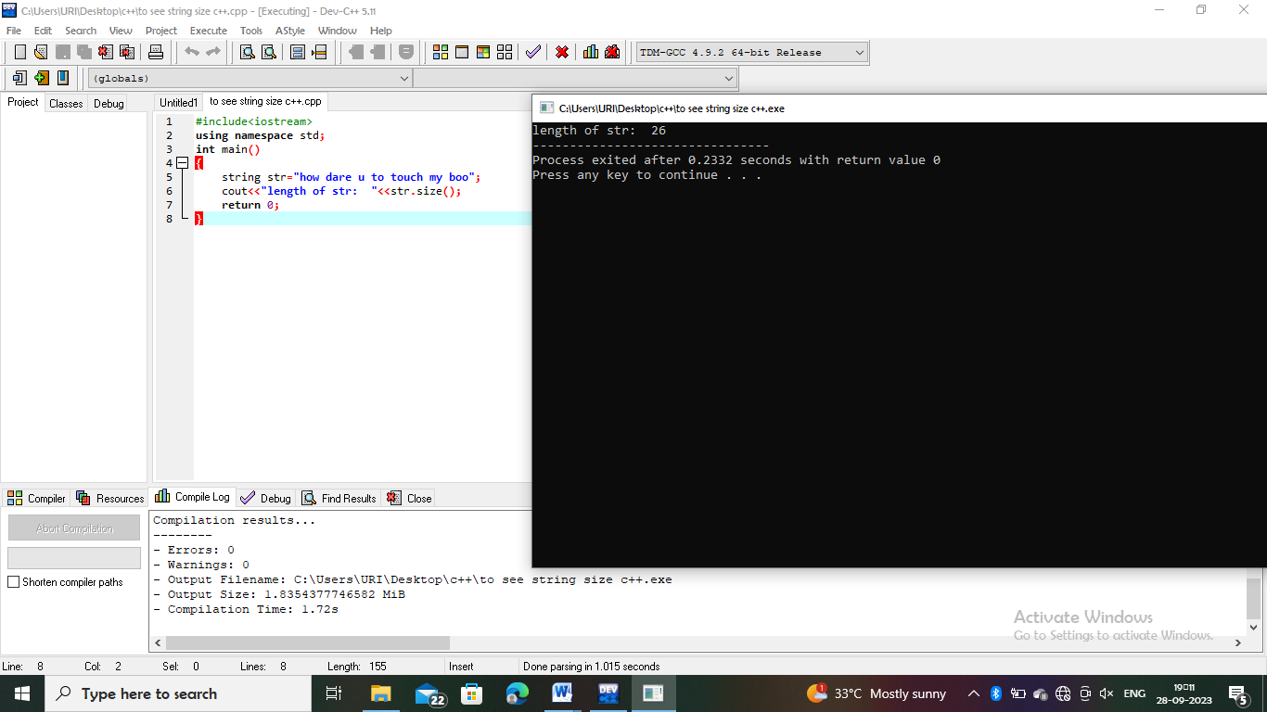

2. C++ Program to Concatenate Two Strings

PROGRAM:

#include <iostream>

using namespace std;

int main()

{

string s1, s2, result;

cout << "Enter string s1: ";

cin>>s1;

cout << "Enter string s2: ";

cin>>s2;

result = s1 + s2;

cout << "Resultant String = "<< result;

return 0;

}

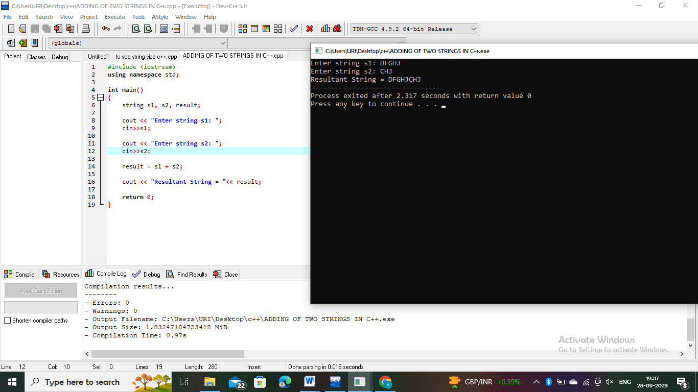

3. C++ Program to Copy Strings

PROGRAM:

#include <iostream>

using namespace std;

int main()

{

string s1, s2;

cout << "Enter string s1: ";

cin>>s1;

s2 = s1;

cout << "s1 = "<< s1 << endl;

cout << "s2 = "<< s2;

return 0;

}

